**TIPS!**

Share the brochure with family & friends!

Smile & identify yourself and your group!

Stay safe when selling; never go to a stranger’s house!

Always say “Thank You!”

**HAVE FUN!**

**GRAND PRIZE DRAWING!**

Valued at $5,000 and sponsored by Savory Sweets

$5,000 College Scholarship

OR

Family Vacation for 4 to Orlando Florida!

Sell 25 units to be entered into the drawing. You will then be entered again for every 25 units on top of the original 25. (ex. 75 units = 3 chances to WIN)

Grand Prize Drawing will be held on or after December 30, 2018

**MY PERSONAL GOAL IS:___________items**

***Earn up to $200*** for your organization by referring another organization to Savory Sweets Fundraising!

**Contact Amy Bay at** [**amy.bay@savoryfoods.com**](mailto:amy.bay@savoryfoods.com) **for more info!**

**Orders due:**

**Order will be delivered:**

**Return order form with check or 1 money order made payable to:**

Questions? Contact:

**PRICES**

Cookie Dough, Caramel Corn, Lava Cakes, Pretzels, Meltaways

**$14 each**

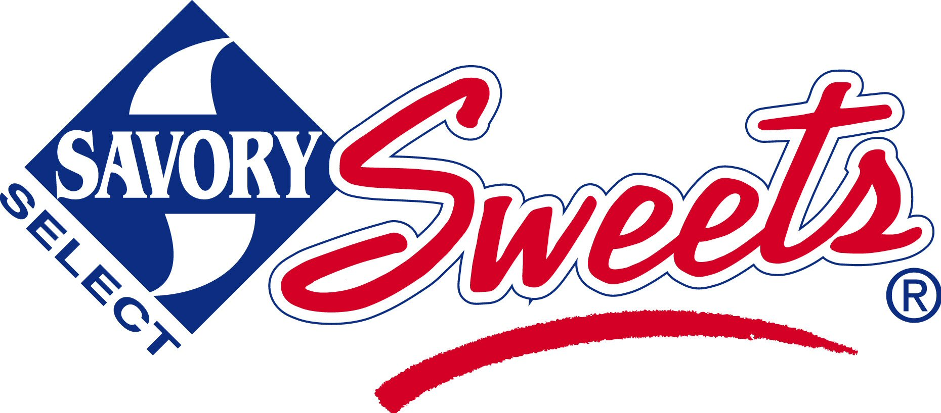Proudly presents a FUNdraiser to benefit:

**GROUP NAME**

**We Need Your Help!**

The students at _____ need your help to make this a successful fundraiser for our school. We are raising money to purchase new playground equipment. **THANK YOU FOR YOUR SUPPORT!**

We are pleased to offer **Savory Sweets Home-style, Ready-to-Bake Cookie Dough, Gourmet Caramel Corn**, **Lava-licious Fudge Cakes and Hand Made Chocolates** for our current fundraiser!

All of these products are **MADE IN MICHIGAN!!!**

**Please share the brochure with others; there’s something for everyone!**

**The money we raise will help us purchase classroom supplies, playground equipment and more!**