

**Orders due:**

**Delivery the week of:**

**Return order form with cash or 1 money order made payable to:**

Questions? Contact:

**EARN GREAT PRIZES!**

Enter your group incentives here

**MY PERSONAL GOAL IS:_________items**

**TIPS!**

Share the brochure with family & friends!

Smile & identify yourself and your group!

Stay safe when selling, never go to a stranger’s house!

Always say “Thank You!”

**HAVE FUN!**

**PRICES**

Cookie Dough, Caramel Corn, Lava Cakes, Pretzels,Seafoam

**$_____ each**

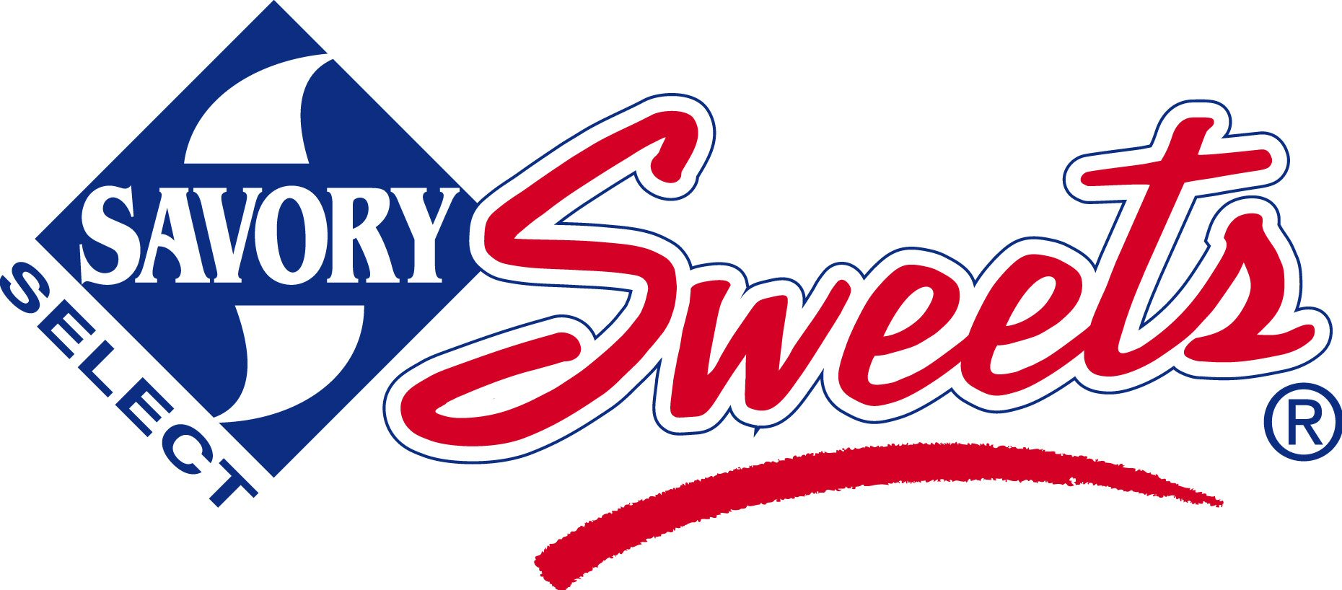 Proudly presents a FUNdraiser to benefit:

Your Group Here

**The money we raise will help us purchase classroom supplies, playground equipment and more!**

We are pleased to offer **Savory Sweets Home-style, Ready-to-Bake Cookie Dough, Gourmet Caramel Corn**, **Lava-licious Fudge Cakes and Hand Made Chocolates** for our current fundraiser!

All of these products are **MADE IN MICHIGAN!!!**

**Please share the brochure with others; there’s something for everyone!**