Savory Foods Tool Kit

Our Savory Foods cookie dough sale is up and running! Get your orders in today and help us reach our goal.

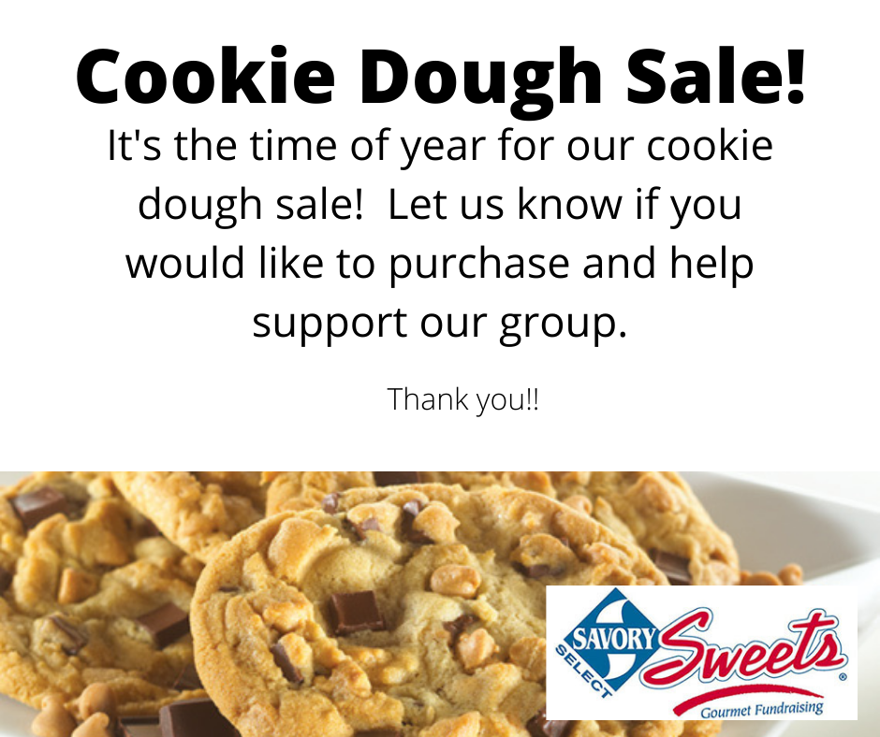

There is one week left of our Savory Foods fundraiser. Have you reached your goal yet? Every bit helps!
